BASUO AUSTRALIAN MEMORIAL

Pilgrimage to Basuo, Hainan, China

In October 2003 ACCCI President Michael Jones and Vice President Marilyn Walker made a pilgrimage to the old City of Basuo, now known as Dongfang County, in Western Hainan Province, China. In particular they visited the Village of Lao Ou where Darwin City Council was finally building the Australia War Memorial so long in the planning.

Not much is known in Australia about the connection with Hainan, nor the Japanese invasion of 1940, which preceded the attack on Pearl Harbor in December 1941. Australian troops captured in the Dutch East Indies, now Indonesia, were first held in prisoner-of-war camps on Ambon Island and thousands later transferred to Basuo on Hainan Island until subsequently liberated by the Americans in 1945.

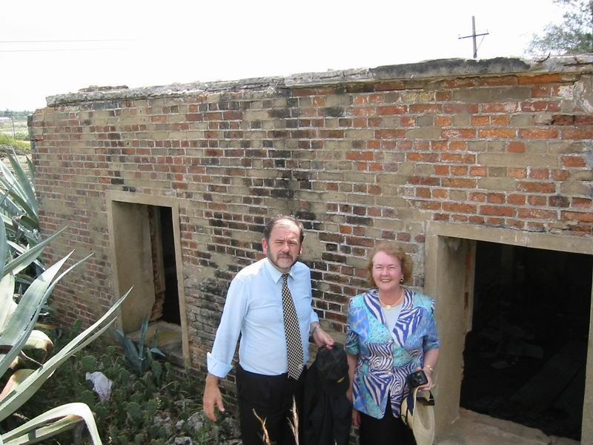

Photo 1 Outside one of the decaying prison buildings in Basuo

Basuo Prison was where almost 300 Australian prisoners-of-war died together with thousands of Dutch, Indian, British and Americans.

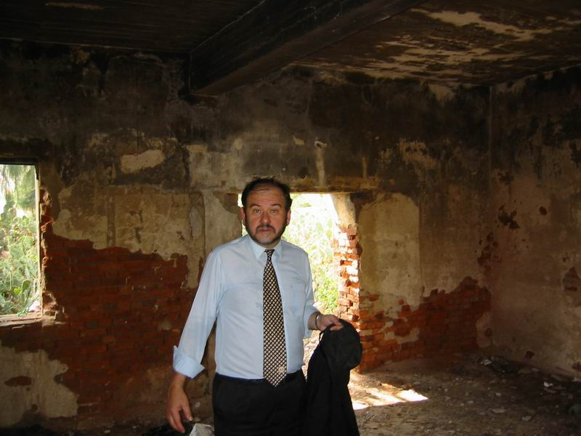

Photo 2 Inside another prison building at Basuo

There is still time to restore some of these buildings as a ‘Legacy of Peace’ for all who suffered there – Chinese, Australian, Dutch, Indians, British, American and Japanese

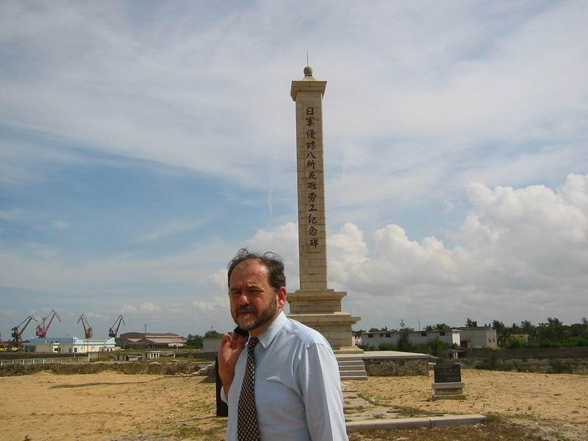

Photo 3:The Basuo Memorial for Chinese dead

The Hainan Provincial Government built this Memorial for over 20,00 forced labourers who died building the railway from Basuo to Sanya City, the major port in the south.

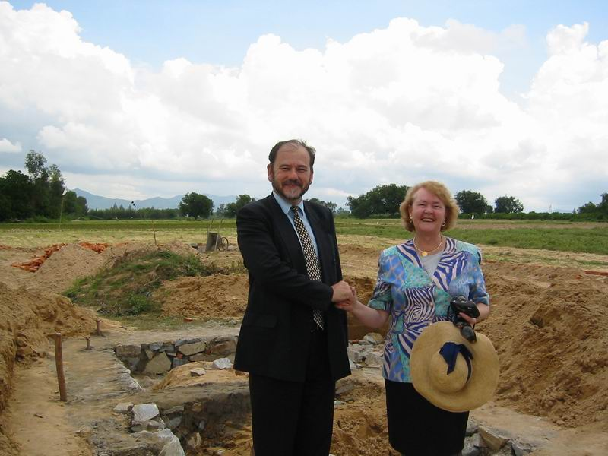

Photo 4:The Australian Memorial under construction

The Australian Memorial in Lao Ou Village is several hours drive from Basuo, and has been build through money donated by the Darwin City Council which historically has had a special relationship with Ambon and Basuo. Darwin and the Northern Territory have Sister City and Sister State Relationships with Haikou City and Hainan Province.

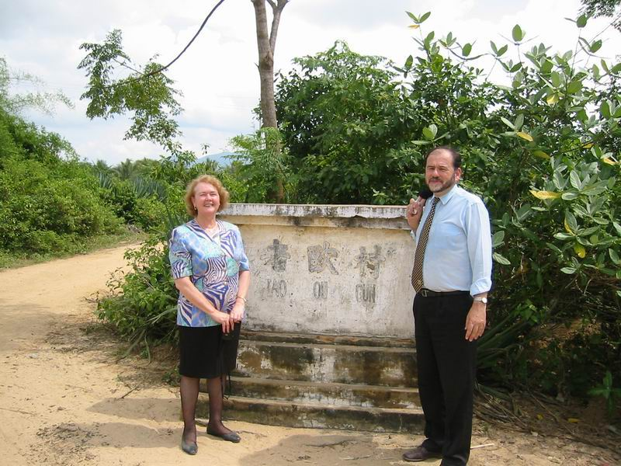

Photo 4: Outside Lao Ou Village

President Michael Jones and Vice President Marilyn Walker at the
Entrance Plaque to Lao Ou Village, Dongfang County, Western Hainan Province, China

