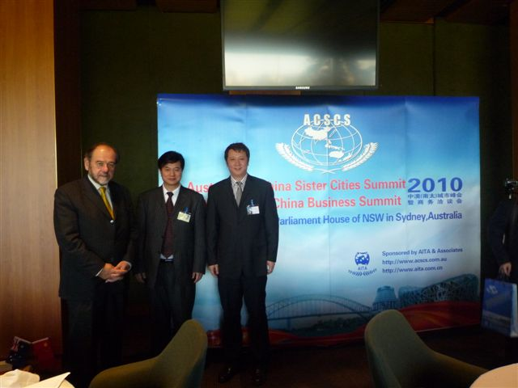

From left to right: Michael C. H. Jones, President of the Australia China Chamber of Commerce and Industry of New South Wales;
Michael Guo, CEO of Australia International Trade Association & Associates, New Zealand International Exchange Centre; and
Stephen Moon - CEO Australian Resource Mining Company

