THE AUSTRALIA-CHINA CHAMBER OF COMMERCE AND INDUSTRY
OF NEW SOUTH WALES
Established in 1976 ACN 002 816 622

Secretariat & Agents Governor: Correspondence to:
National and International The Lord Mayor of Sydney, G.P.O. Box 3671
ACCCI Pty. Limited Patron: Sydney NSW 1044
ACN 008 613 590 The Consul General of the Telephone 61 2 9451 3130

People’s Republic of China Facsimile 61 2 9451 3575

E-mail to: chamber@accci.com.au

ANNUAL ACCCI FORUMS

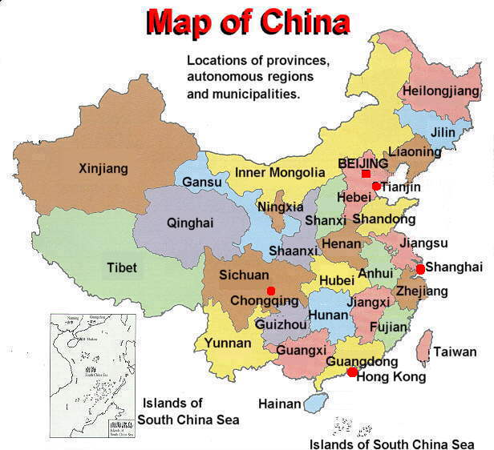

The purpose of the Annual ACCCI Forums is to bring together the best experts from business, academia and government in both China and Australia with the objectives of analysing global trends in industry, commerce and services; identifying business opportunities and resolving market problems to mutual satisfaction.

Four broad Trade Policy Committee forums are designed to link Australian business to China’s socio-economic aspirations concerning:

- The need to find jobs through Rural Industries for nearly 800 million people.
- The challenge of massive migration to the cities, now over 500 million, which requires the provision of Urban Services.
- The integration of China both domestically between provinces and cities and internationally with other countries via the range of Infrastructures.
- The demand of a growing middle class consumer society for Commercial Culture outside government direction and funding.

The ACCCI Commercial Committee Special Projects dovetail into each of these areas:

- The AIIP promotes Chinese direct investment in Australian capabilities.
- The AITCP seeks Chinese partnerships for commercial development to market.
- The AEBTCP encourages Chinese specialisation in Australian management.
- The ATSSP fosters reciprocal business visitations in specialised areas.

The Public Affairs and Cultural Committees back up this effort through emphasis on international norms of behaviour and understandings of historical and philosophical factors.

These Annual ACCCI Forums will act as a Clearing House for business ideas and systems. They can only succeed if ACCCI organisation at all levels is superior to those of other bodies. This is the task of the ACCCI Secretariat supported by the CLC and NLC.

Chamber needs to properly target the most appropriate speakers, addressing topics of genuine importance, and then create the intellectual environment for concrete identification of business opportunities and problems in the medium to long term.

Our objective remains “the establishment of strong and lasting economic linkages between non-government organisations in Australia and China”.

All recommendations and suggestions from member companies and friendly organisations are most welcome.

